

ODK Readiness Newsletter

July 1998

Volume 1, Issue 1

Contents
- Introduction to ODK
- Getting Started
- Requirements for install

Page 1

- PRFADMIN
- Language Support
- What installs
- List of Switches
- Internet Explorer SP1 support

Page 2

- Knowledge Base Articles
- Customer Top Issues

Page3

FAQ

Page 4

Quick Links

Patches and updates
ftp://ftp.microsoft.com/Softlib/Msfiles

In depth Doc.
http://www.microsoft.com/office/download/O98DKdoc.exe

Why should I use the ODK?

Communication in the workplace has become an essential part of the business world. In the last few years e-mail and executive scheduling has become a necessity for the corporate machine. As corporations prosper and the number of client desktops grows into the tens of thousands, the need for efficient, well-planned deployment becomes crucial to business success. This is part of the concept of Total Cost of Ownership (TCO). The goal of the developers is to make a tool that provides the Outlook 98 setup easy to configure for administrators by moving configuration of the client to the backend so that the desktop itself has little, if anything, to configure. The idea is simple: make an install that is customized for a large group of users, such as a department, and the administrator has to configure the installation only once. This saves in administrative overhead as well as time saved at the desktop, normally spent on configuration.

How do I get started?

The best place to start understanding the ODK is the Microsoft Outlook 98 ODK Administration Guide. Other great resources are the help files and the readme.doc that are installed with the ODK.

What version do I have?
Match properties of C:\program files\odk\odkwiz.exe against the table below:

Outlook 98 ODK Version History
Build Number Distributed on 8.5.5104.7 April Select CD
8.5.5104.9 May Select CD
8.5.5104.9 Exchange 5.5 SP1

In the earlier versions of ODK there was a problem encountered with silent installs (Q179432) fixed by ODKPATCH.EXE, which can be downloaded from ftp://ftp.microsoft.com/Softlib/MSFILES/ODKPATCH.exe.

Once you have created your first package, you need to check the setup.ini file in the (packagename)\cd\en\packages directory for the

CDKey = (value) If this states CDKey=web, the patch did not apply. Exchange 5.5 SP1 will include the ODKPATCH.EXE
More information: Q179432: Outlook 98 Error Trying to Install in Quiet Mode
When you use the Outlook 98 Deployment Kit from the April or May Select CD Kit to deploy Outlook 98 and either select the Silent Install option in the actual wizard or use the following command line: setup.exe /Q:A /C:"outlwzd.exe /S:""#e"" /Q /R:N". The installation errors out at the very beginning with the following message:
Error: Setup cannot find a properly configured setup.ini file for quiet mode. Consult the Outlook 98 Deployment Kit for information on creating quiet mode installations. Do you wish to continue installing without quiet mode?
This problem appears only in the Select CD distribution of the Outlook 98 Deployment Kit in silent mode installations. This does affect Select CDs in non-silent mode or any other distribution of the ODK in silent mode.
A patch has been created to resolve this issue. To apply the patch, run the executable on the machine that has the ODK installed, before building a custom Outlook 98 package. All packages that are already built need to be rebuilt after the patch is applied to the ODK. A KB article will be posted shortly at http://support.microsoft.com/support/kb/articles/q179/4/32.asp detailing this issue you can obtain this patch at: ftp://ftp.microsoft.com /Softlib/MSFILES/ODKPATCH.EXE

What do I need in order to install the ODK?

You will need 125 MB of free space available on the C drive of the ODK machine (Q182168).
Note: You must have Internet Explorer 4.0 (or later) installed before using the Outlook 98 Deployment Wizard. This version of the wizard works with Windows 95, Windows NT 4.0 Server, and Windows NT 4.0 Workstation Service Pack 3 (and later versions of these products).
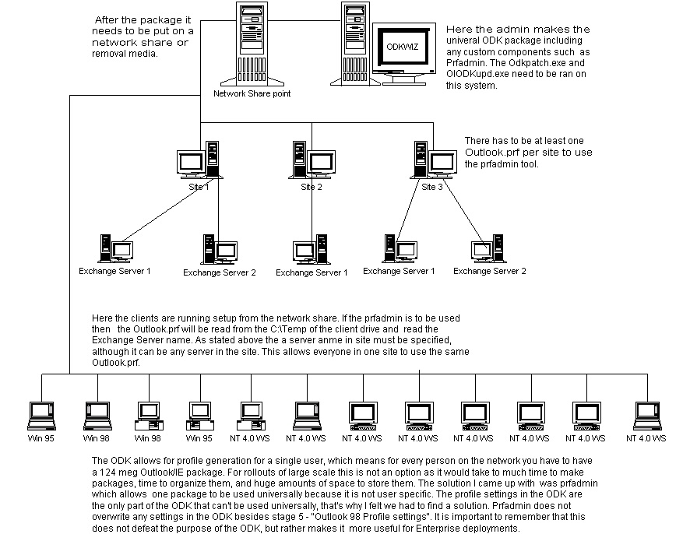

Does PRFADMIN assist with generating profiles?

The ODK allows for profile generation for a single user, which means every user would need their own 124 MB Outlook/IE package. For large scale rollouts this is not an option, as it would take too much time to create and organize packages, not to mention huge amounts of space to store them on. The solution is the prfadmin utility, designed to help network administrators quickly and easily set up profiles on client computers with the ODK. It uses Profgen.exe and the Outlook.prf file for settings.
What to do:
- When you run the self-extracting Prfadmin.exe file, you will receive a prompt for the location to extract to. The default folder is C:\Temp. It is crucial that you use this location or the kit will fail. Do not move the files from this location.
- In stage two “Specifying Active Setup parameters” of the ODW, where you configure custom components, add Prfadmin.exe Add outlook.prf to the users' C:\Temp folder. This starts Prfadmin on the client computer after Outlook 98 is installed.
NOTE: It is important that you log on as the user, not the administrator, to install the Outlook 98 pack files.
- You must supply the name or IP address of your Exchange Server in Outlook.prf on the client computer. The mailbox will be configured dynamically when the user logs on. Other customization in the ODK is optional.
- You must add the Prfadmin.exe to generate the users' names. Next, the Exchange Server name must be added into the "HomeServer=" section of Service 2 in the Outlook.prf. This makes a package for each server rather than each user. Because Outlook checks the Global Address List (GAL) and connects each user to the correct Exchange Server, only one server per site has to be used.
For example, if there are five Exchange Servers with 5,000 users each, only five packages must be created. (One for each Exchange Server, rather than one for each user.) If a single Outlook.prf is used, only one universal package is required.

Where can I find PRFADMIN?

For more information on PRFADMIN refer to Readme.doc. Get PRFADMIN by downloading ODKPRFAD.EXE from ftp://ftp.microsoft.com/Softlib/MSLFILES/.

Does the ODK support different Languages?

Although the Outlook 98 Deployment Wizard (ODW) can customize any language version of Outlook 98, it only comes with one pre-installed language. To add additional languages to the ODW, use the ODKLang.exe tool to copy the necessary Outlook 98 language files into your ODW directories. ODKLang.exe is located in the \Tools directory of your ODW installation. It will prompt you for an Outlook 98 CD before it copies files into your ODW directories. The copied files will appear under the \ODK\Download\xx and \ODK\olbin\xx directories, where xx stands for the language code of that copy of Outlook 98. After you have used ODKLange.exe to add additional languages, the ODK will display these available languages in the stage one “Select a Language” dialog box. English is the only language that supports 128 bit encryption, because 128-bit encryption is not exportable.
IE installed w/Outlook98?

You must Install Internet Explorer (Minimal Install) and Outlook Express. Outlook 98 is integrated with Internet Explorer and Outlook Express, so you cannot remove these programs from an Outlook 98 installation.
Where is the list of switches?

After you use the ODW to create one or more customized Outlook 98 installations, you can run the Setup program from the command line. If you do, you can add parameters to the command that allow you to specify certain options, such as choosing a standard installation or specifying quiet mode (which removes or reduces the prompts the user receives). These options are outlined in Q189520.
Can I roll out IE4 SP1 with the ODK?

Currently there is no supported way to automatically install IE 4.01sp1 with the ODK. We currently have no plans to re-release Outlook 98 that incorporates IE 4.01 SP1.

Install model using PRFADMIN

Knowledge Base Articles
Q184550 Outlook Deployment Kit (ODK) Availability
Q172046 Patch for Outlook Deployment Kit on April Select CD
Q187808 Configuring Outlook 98 Profile Settings in the ODW
Q187527 Profile Administration Kit Available
Q184951 Multiple Lines for Installation Description Truncated
Q184409 Fax Support Not Deployable with ODW
Q184336 Message Format Unavailable After Outlook 98 Installed
Q184290 Unable to Load Out98prf.adm with Poledit
Q184250 Rerun Outlook 98 Setup Fails on Customized Install
Q184249 Setup Fails Installing from ODK Over Old Installation
Q184070 Opened in Outlook Today Starts Internet Explorer
Q183778 ALT+TAB Shows Two ODK Icons
Q182709 Specifying Active Setup Parameters Is Confusing
Q182168 Cannot Specify Outlook Deployment Kit Install Folder
Q179432 Silent Install Fails with Outlook Deployment Wizard
Q189140 How to Remove the Outlook Express Icon Using ODK
Q183779 Can't Clear Combo Boxes in Policy Editor
Q148664 Description of the Profile Descriptor File
Q188062 SMS support for Outlook98 to a NT client

For index of top Microsoft KB articles - send mail to MSHELP@microsoft.com with no subject.
For a specific Microsoft KB article - send mail to MSHELP@microsoft.com with the Q# as the subject.

Customer Top Issues

Issue 1:
Customer: I have just install Outlook 98 on a client machine from my ODK package and none of my settings are working. There is no profile generated and my setting that would be under Tools/Options like autoarchive are not changing. What’s wrong?

Engineer: If you have a profile already on the machine the ODK detects the profile and preserves the settings for the profile and custom settings that would be in the Tools/Options. There is an article that further explains how the custom setting and profile generation works in the ODK. Q187808 Configuring Outlook 98 Profile Settings in the ODW

Issue 2:
Customer: I have roaming users and I need to generate profiles on the machine for each user that signs on but the ODK only lets me specify one exchange server and one mailbox. Do I have to create an ODK package for every user?

Engineer: No, you do not have to make a separate package for each user. We have a tool just for this issue that you can use to generate your profiles. This is a standalone tool that will create a profile on the machine based on the user logon. You can get the tool at ftp://ftp.microsoft.com/Softlib/MSLFILES/odkprfad.exe this is further explained in Q187527 OL98: ODK Profile Administration Kit Available.

Issue 3:
Customer: I ran the ODW (Outlook Deployment Wizard) and I am running the setup for silent mode with no reboot using the R:N switch but the machine is still rebooting.

Engineer: Alot of customers are running the setup.exe from the X:\<specified directory>\setup.exe. This will not work correctly. Also, if you run setup from the CD directory, it fails, but if you go into packages and then run setup, it works.
1. It is important the line be input character for character with the quotes balanced and in the correct location as shown in the example line below:
x:\<specified directory>\cd\en\packages\setup.exe /Q:A /C:"outlwzd.exe /S:""#e"" /Q /R:N"
(Of coarse this is for a English install I have not tried any foreign language quiet install yet)
2. The setup.exe file must be run from the packages location:
x:<destination you specify>\cd\en\packages\setup.exe
(Where "x" is the drive and "destination you specify" is the directory you said for your install package)

Issue 4:
Customer: I installed to the client computers using my package I created with the ODK. When I was going through the wizard I selected the option to not put the IE icons on the desktop but when I check the desktop IE and OE icons are both there!

Engineer: The ODK will place the IE and OE icons on the desktop when setup is completed. After running Outlook for the first time the IE and OE icons are removed if they were not on the desktop prior to running Outlook setup. We have a utility that can be added in the "Specify Active Setup Components" screen in the ODK that will remove the OE icon from the desktop. That utility can be found on our FTP site at: ftp://ftp.microsoft.com/Softlib/MSLFILES/ol98qfe2.exe. Check out Q189140 OL98: ODK: How to Remove the Outlook Express Icon Using the ODK for more information.

Advanced Tips

How to create one package for a large number of Exchange users who DO NOT have existing profiles on their machines.

- In Stage 5 of the ODW, ‘User Settings Customization’, drilldown to the Outlook Profile Settings\Exchange Settings tree.
- In the "The name of the user’s mailbox" entry, type something like, ‘<Enter user name here>’ (without quotes).
- In the "server name" entry, type any valid Exchange Server in the Exchange Site.
- Check to resolve mailbox name at run time.
- To finish up include whatever service you want. This is found under the Outlook Profile Settings\General.

The first time the user launches Outlook, their profile will attempt to resolve a mailbox name called "<Enter user name here>". Because this is an invalid mailbox, the users will be prompted for a valid mailbox. The dialog box will read "<Enter user name here>. The user will then type in their correct user name or mailbox alias and it will resolve properly.

Frequently Asked Questions

This Frequently Asked Questions section has been written to address many reoccurring questions in an attempt to better educate Engineers regarding the ODK and questions that customers may ask.

Q: Does the ODK work with Outlook 97?

A: No, it does not. The ODK was designed to with Outlook 98 and is aware of its components through the Active Setup engine. Outlook 97 was designed around the Acme setup engine, which is not compatible with the ODK.

Q: Can I use the .prf files I used on the Outlook 97 clients in the ODK 98?

A: Yes, and no. The ODK does not support .prf files directly although, the program “profgen” will. This was done away within the ODK to simplify the complex and often little known prf entries to complete GUI to make configuration quicker and easier. A more recent tool that is now available is “prfadmin” which is a preconfigured “profgen” and can be used with login scripts, stand-alone, or bundled with the ODK.

Q: I have users in Outlook 97 (or Exchange client) already and wish to retain the profiles I already have but want to use the ODK for everything else. How do I do it?

A: Continue the ODK steps until you reach stage five. When it prompts you for user information about the profile leave it blank. It will not add anything for profiles and will use the existing profile selected in Mail (and Fax) in Control Panel.

Q: Will the ODK installation retain access permissions for delegates on the new calendar folder?

A: The ODK does not import permissions, only the data for the calendar.

Q: Can you alter the default welcome message to something else?

A: You cannot alter it directly but there is a workaround; Compose a new welcome message and save it as “welcome.msg”. Next, create an Iexpress self-extracting .exe with a .inf file, which copies the new message to the Outlook directory. Finally, using the Outlook 98 ODK, add the Iexpress file you created as a custom component.

Q: Does the ODK synchronize with the bits on a web site like the IEAK does?

A: No, the ODK does not synchronize when newer versions come out. This is the major difference between the ODK and IEAK. Anytime a new version of Outlook 98 is made; we will have a corresponding ODK.

Q: I used the IE40 admin kit and the browser info that I have to fill out in the ODK is redundant; is there anyway to import some of this information over from one to another?

A: No, this information must be re-entered manually.

Q: If I already have IE401 installed will the ODK install it again?

A: No, it Outlook 98 will not install IE401 if it’s already on the user’s machine, unless you choose to customize the browser setting in the ODK.

Q: Can the ODK be installed without IE 4.0x?

A: No, the ODK requires at least some of the basic IE files due to the nature of Active Setup. In the custom components section of the ODK you should see a that those basic files are not removable.

Q: Can you use .prf files with the Outlook 98?

A: Yes, but not in the sense that 97 used it. Here’s how it stands; in the reg key HKLM\Software\Microsoft\Office\8.0\Outlook\Setup\PRF there is basically the information and format as the .prf used in Outlook 97. If the user has no profile in this reg key during first run then newprof.exe will look for an Outlook.prf in the same dir as Outlook.exe.

Q: How do I install the ODK silently? I don’t want to have to do any of the settings on the backend.

A: There is no silent install on the ODK itself, only the packs it makes. There is no way known to populate those fields in the ODK with an ini file.

Q: Do you still need the patch if you’re running the May CD?

A: Yes, you must uninstall the April if you have it, re-install the May ODK, then run the patch.

Q: Will the Outlook 98 ODK install on NT 3.51?

A: No. Outlook 98 requires NT 4.0 or Windows 95. Outlook97 which ships in Office 97 and Exchange 5.0 supports NT 3.51 (and Windows 95), and thus we recommend 3.51 customers to deploy Outlook97 instead.

